CS 257 Database and Information Systems Lab

Assignment 4: Database Design

Online Shopping Comparison DBMS
Project team:
Mallhar Arvind Totey — 250041026
Aditya Barman — 250001005
Aryan Gothwal — 250001010

Part A — Entity Relationship (ER) Diagram
The diagram below uses classic Chen ER notation:
• Rectangles = entities (double-lined rectangle = associative / bridge entity)
• Diamonds = relationships, named with a verb phrase
• Ovals = attributes of the entity they are attached to; an underlined attribute name is the Primary Key (PK)
• Labels (FK) and (UK) on an attribute mark Foreign Key and Unique constraints respectively
• Numbers on the lines connecting entities to relationships show cardinality — 1 or M (many)
The full-size diagram is on the next page (landscape) for readability.

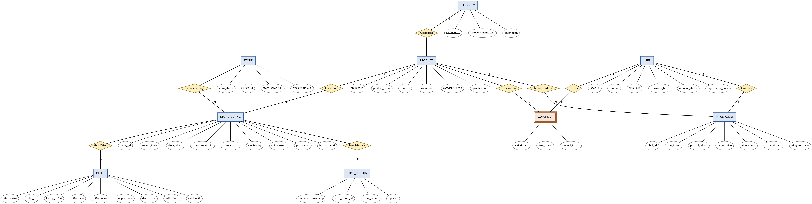
Figure 1. ER diagram — Online Shopping Comparison DBMS (Chen notation)

Part B — Relational Database Schema
Each ER entity below maps to one relational table. PK = Primary Key, FK = Foreign Key, UK = Unique constraint.
1. CATEGORY
Column | Data type | Key | Constraints
category_id | INT | PK | NOT NULL, AUTO_INCREMENT
category_name | VARCHAR(100) | UK | NOT NULL, UNIQUE
description | TEXT | — | NULL allowed
2. PRODUCT References: category_id → CATEGORY(category_id)
Column | Data type | Key | Constraints
product_id | INT | PK | NOT NULL, AUTO_INCREMENT
product_name | VARCHAR(200) | — | NOT NULL
brand | VARCHAR(100) | — | NOT NULL
description | TEXT | — | NULL allowed
category_id | INT | FK | NOT NULL, REFERENCES CATEGORY(category_id) ON DELETE RESTRICT
specifications | JSON / TEXT | — | NULL allowed
3. STORE
Column | Data type | Key | Constraints
store_id | INT | PK | NOT NULL, AUTO_INCREMENT
store_name | VARCHAR(100) | UK | NOT NULL, UNIQUE
website_url | VARCHAR(255) | UK | NOT NULL, UNIQUE
store_status | VARCHAR(10) | — | CHECK (store_status IN ('ACTIVE','INACTIVE')) DEFAULT 'ACTIVE'
4. STORE_LISTING References: product_id → PRODUCT, store_id → STORE
Column | Data type | Key | Constraints
listing_id | INT | PK | NOT NULL, AUTO_INCREMENT
product_id | INT | FK | NOT NULL, REFERENCES PRODUCT(product_id) ON DELETE CASCADE
store_id | INT | FK | NOT NULL, REFERENCES STORE(store_id) ON DELETE CASCADE
store_product_id | VARCHAR(100) | UK* | NOT NULL, UNIQUE together with store_id
current_price | DECIMAL(10,2) | — | NOT NULL, CHECK (current_price >= 0)
availability | VARCHAR(15) | — | CHECK (availability IN ('IN_STOCK','OUT_OF_STOCK'))
seller_name | VARCHAR(150) | — | NULL allowed
product_url | VARCHAR(500) | — | NOT NULL
last_updated | TIMESTAMP | — | NOT NULL, DEFAULT CURRENT_TIMESTAMP
* UNIQUE (store_id, store_product_id) — composite unique constraint.
5. PRICE_HISTORY References: listing_id → STORE_LISTING
Column | Data type | Key | Constraints
price_record_id | INT | PK | NOT NULL, AUTO_INCREMENT
listing_id | INT | FK | NOT NULL, REFERENCES STORE_LISTING(listing_id) ON DELETE CASCADE
price | DECIMAL(10,2) | — | NOT NULL, CHECK (price >= 0)
recorded_timestamp | TIMESTAMP | — | NOT NULL, DEFAULT CURRENT_TIMESTAMP
6. OFFER References: listing_id → STORE_LISTING
Column | Data type | Key | Constraints
offer_id | INT | PK | NOT NULL, AUTO_INCREMENT
listing_id | INT | FK | NOT NULL, REFERENCES STORE_LISTING(listing_id) ON DELETE CASCADE
offer_type | VARCHAR(15) | — | CHECK (offer_type IN ('COUPON','DISCOUNT','CASHBACK'))
offer_value | DECIMAL(10,2) | — | CHECK (offer_value >= 0)
coupon_code | VARCHAR(50) | — | NULL allowed
description | TEXT | — | NULL allowed
valid_from | DATE | — | NOT NULL
valid_until | DATE | — | NOT NULL, CHECK (valid_until > valid_from)
offer_status | VARCHAR(10) | — | CHECK (offer_status IN ('ACTIVE','EXPIRED'))
7. USERS
Column | Data type | Key | Constraints
user_id | INT | PK | NOT NULL, AUTO_INCREMENT
name | VARCHAR(150) | — | NOT NULL
email | VARCHAR(150) | UK | NOT NULL, UNIQUE
password_hash | VARCHAR(255) | — | NOT NULL
account_status | VARCHAR(10) | — | CHECK (account_status IN ('ACTIVE','BLOCKED')) DEFAULT 'ACTIVE'
registration_date | DATE | — | NOT NULL, DEFAULT CURRENT_DATE
8. PRICE_ALERT References: user_id → USERS, product_id → PRODUCT
Column | Data type | Key | Constraints
alert_id | INT | PK | NOT NULL, AUTO_INCREMENT
user_id | INT | FK | NOT NULL, REFERENCES USERS(user_id) ON DELETE CASCADE
product_id | INT | FK | NOT NULL, REFERENCES PRODUCT(product_id) ON DELETE CASCADE
target_price | DECIMAL(10,2) | — | NOT NULL, CHECK (target_price > 0)
alert_status | VARCHAR(10) | — | CHECK (alert_status IN ('ACTIVE','TRIGGERED','DISABLED')) DEFAULT 'ACTIVE'
created_date | DATE | — | NOT NULL, DEFAULT CURRENT_DATE
triggered_date | DATE | — | NULL allowed
9. WATCHLIST (associative / bridge entity) References: user_id → USERS, product_id → PRODUCT
Column | Data type | Key | Constraints
user_id | INT | PK, FK | NOT NULL, REFERENCES USERS(user_id) ON DELETE CASCADE
product_id | INT | PK, FK | NOT NULL, REFERENCES PRODUCT(product_id) ON DELETE CASCADE
added_date | DATE | — | NOT NULL, DEFAULT CURRENT_DATE
Composite Primary Key: (user_id, product_id) — resolves the M:N relationship between USERS and PRODUCT.

